INTRO
RILETTURA
REFERENCES
Title: Adaptive force control of advanced hand prostheses using
surface electromyography: initial results on a patient (case report)
Authors:
Claudio CASTELLINI, Ph.D, University of Genova, Italy
Emanuele GRUPPIONI, M.Eng., INAIL Centro Protesi, Vigorso di Budrio, Italy
Angelo DAVALLI, M.Eng., INAIL Centro Protesi, Vigorso di Budrio, Italy
Giulio SANDINI, M.Sc., Italian Institute of Technology, Genova, Italy
Short title:
Adaptive EMG-controlled prostheses
Corresponding author:
Claudio CASTELLINI
LIRA-Lab, University of Genova
viale F. Causa, 13 – 16145 Genova, Italy
phone +39 338 413 4970
fax +39 010 353 2948
email claudio.castellini@unige.it
Abstract
Objective. We aim at showing that adaptive methods for force control of polyarticulate hand prostheses, namely machine learning applied to electromyography (EMG), can be successfully employed by amputees. Subjects/Patients. A 64 y.o. male, left-side first proximal trans-radial amputee joined the experiment. He underwent surgery in 1963 and has been using myoelectric prostheses since then. His stump is about 8-9 cms. long. Methods. A Support Vector Machine (SVM) was trained on the patient’s EMG patterns, recorded while the subject was required to perform imaginary grasp patterns. A force sensor was used to train the machine in three different ways (teacher imitation, bilateral action and mirror-box). Results. The SVM can distinguish 5 different patterns up to a precision of about 96%; it is as well able to generate the amount of force required by the patient, generating a signal up to 88% correlated to the patient’s will. Conclusion. Our technique, we argue, can be successfully applied to control in a natural, relatively cheap, non-invasive way a polyarticulate prosthesis such as, e.g., Touch Bionics’s i-LIMB, at least in the case of this subject. It is actually surprising that so much precise muscular activity is left in the patient’s stump 45 years after the operation.
Journal: Journal of Rehabilitation Medicine
Principal author: Claudio CASTELLINI, LIRA-Lab, University of Genova, viale F. Causa, 13, 16145 Genova, Italy, email claudio.castellini@unige.it
Keywords: Artificial Limbs [E07.695.050], Artificial Intelligence [L01.224.065], Robotics [L01.224.065.630], Man-Machine Systems [J01.293.556.441], Amputees [M01.150.100]
Introduction
The control is one of the main aspects concerning the clinical application of upper-limb active prostheses. Current solutions are based on electromyographic signals (EMG) and on electronic switches. In the former case, which is also the most common, EMG sensors are placed inside a socket customized for each patient. The EMG sensors detect the electrical signals produced by residual muscles on the epithelial surface of the stump.
An electronic control unit is responsible for processing of the EMG signals and based on the signals received activates the motors of the prosthesis. In this way, therefore, the patient is able control the specific movements of the prostheses, e.g. trans-radial amputees typically can open and close the electro-mechanical hand of their prostheses by using the flexor- extensor muscles of the wrist.
The main problems of these prosthetic technique are:
- long training curve for the patients due to the unnatural control solution;
- incomplete restoration of arm functionality, due to the limited number of degrees-of-freedom of the prosthetic arm compared to the natural arm.
Recently, bionic technologies have substantially improved the prosthetic devices commercially available. An example is the new Touchbionics i-LIMB hand. By placing miniaturized motors in each finger, this prosthetic hand is able to realize more natural movements than the single-joint hand and it also perform a more adaptive grasp.
However, even in this advanced hand, the control strategy is unchanged: the opening and closing movements are performed by all the fingers simultaneously based on the contraction of flexor-extensor muscles of the wrist.
The research of new more “natural” control solutions, which can realize a better correspondence between the thought movement by the patients and the performed movement by the prosthesis appears therefore a mandatory step to improve the amputees’ autonomy in everyday life. In the future these solutions, together with the improvement within bionic technology, could give many advantages in clinical rehabilitation.
Methods
The patient is a 64 y.o. male, Italian, left-side first proximal trans-radial amputee (see Figure 1(a)). He underwent surgery in 1963 and has been using myoelectric prostheses since then. His stump is about 8-9 cms. long (Figure 1(b)). To record the EMG signal, five OttoBock MyoBockTM electrodes were used, evenly placed around his stump (Figure 1(c)). We also used a FUTEK LMD500 force sensor to associate EMG patterns to the required force. A standard digital acquisition card was used to acquire the signals at a sampling rate of 100Hz.
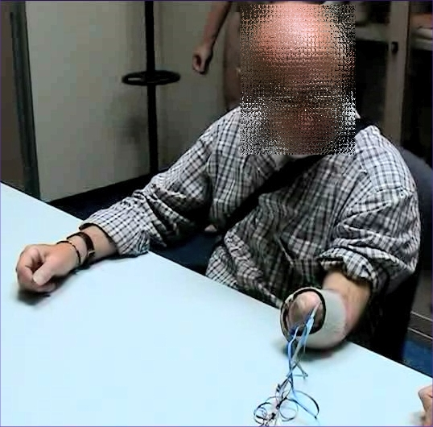 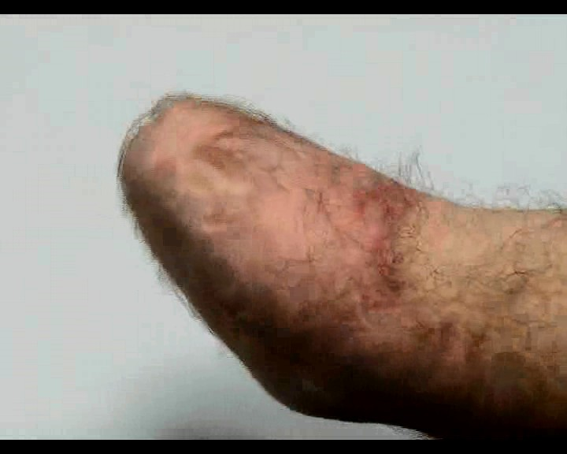 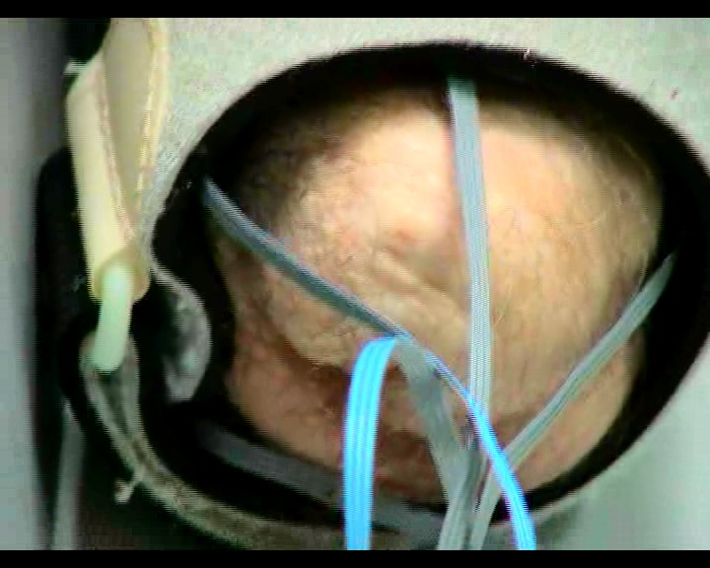
Figure 1: (a) (b) (c)
The patient was asked to “perform” 5 different grasps/postures (no action, pointing index, index pinch grip, tripodal grip, power grasp) with free force and speed, while we would record the EMG and force sensor activity. Three ways of training the system (modalities) were employed:
1. teacher imitation. A healthy subject (teacher) would place his left arm besides the patient’s stump and ask him to “imitate” the grips. The subject was asked to imagine gripping with his maximum strength.
2. bilateral symmetric action. The patient was asked to grip the force sensor with his healthy hand while “doing” the same things with his stump.
3. mirror-box. Same as modality 2, but a mirror was placed between the patient’s arms, in order to increase the visual feedback (5).
Figure 2 shows the patient in action during the three modalities.
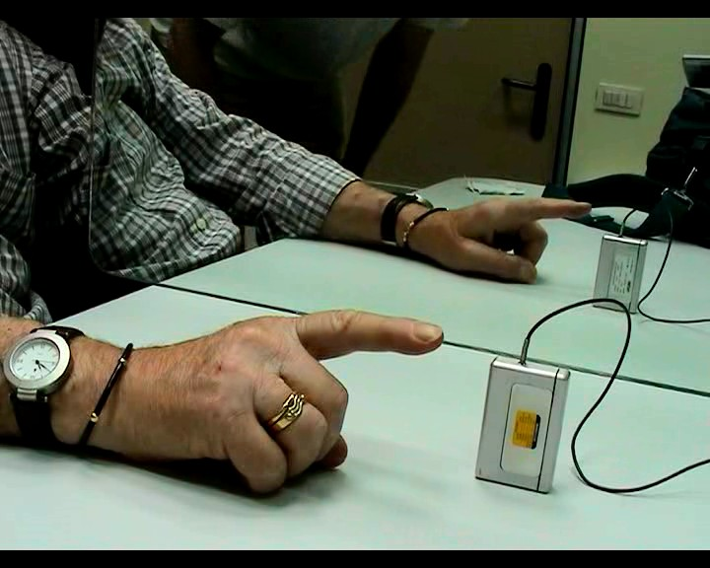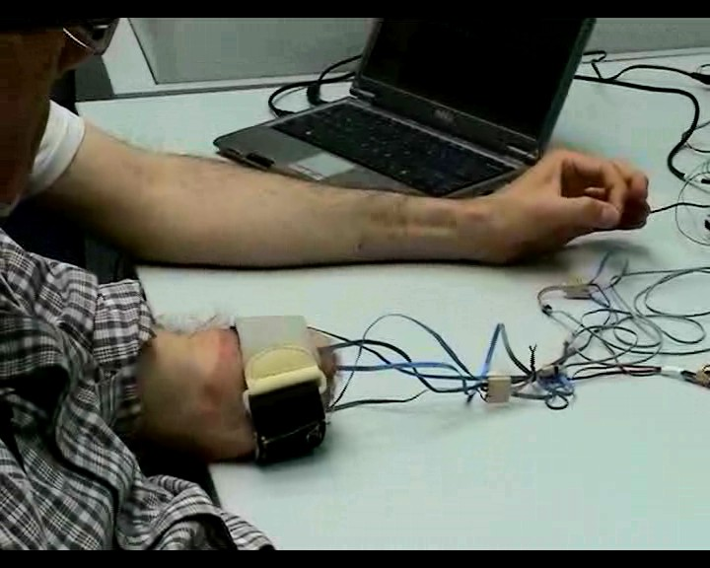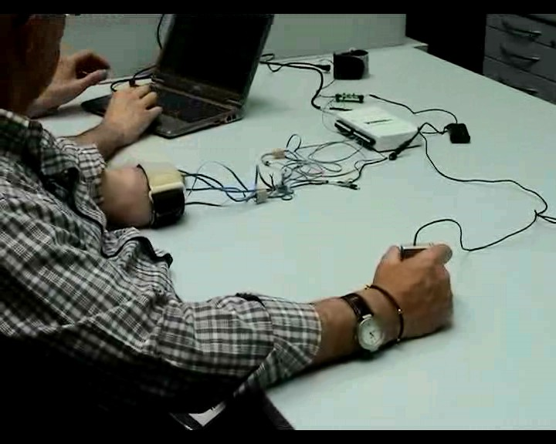
Teacher imitation Bilateral symmetric action Mirror-box
Figure 2
Spectral analysis of the EMG signals reveals that, as is well-known (6), the relevant bandwidth lies below 10-15Hz (the OttoBock electrodes already perform an RMS operation); so the signals have been subsampled at 25Hz from the original 100Hz. Categories were assigned to samples according to the type of grasp the subject was asked to perform; the force value was, in the case of modality #1, the maximum possible, and the sensor was pressed by the teacher himself. Samples with low force values were removed from the data set.
To start with, Principal Component Analysis reveals that the 5 signals can be reduced to 2 without losing more than 10-15% variance.
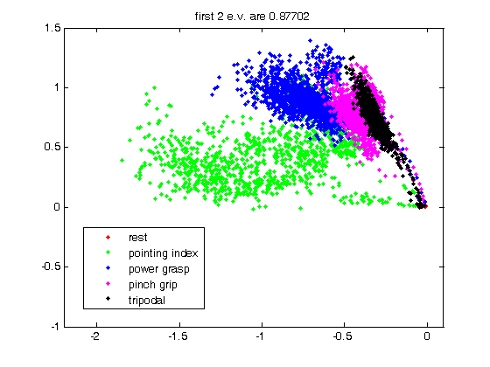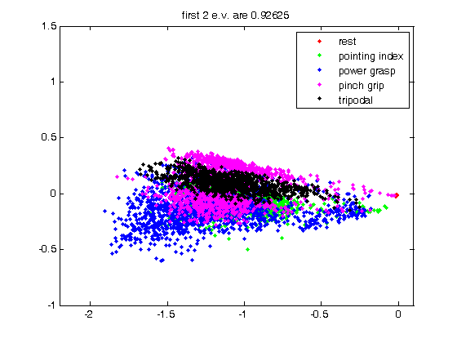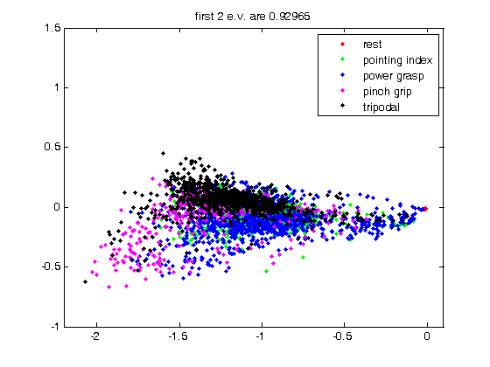
Figure 3
Visual inspection of the samples, coloured according to the grasp type required (see Figure 3), further reveals that the grasps produce remarkably well-identifiable samples, especially in the case of teacher imitation, and that teacher imitation is, from this point of view, by far better than the other two modalities.
Subsequently, a Support Vector Machine (SVM – see 20) was trained on the acquired data. SVMs are a statistical learning method able to reconstruct, with a provably low error, a function associating values in an input space to values in an output space. In our case, the input space is given by the EMG values, and the output space is two-fold: the machine is asked to detect both (a) which kind of grasp the patient is applying (classification); and (b) how much force the patient is trying to apply (regression).
Results
In the following, as a measure of performance, we present the classification accuracy ratio for the classification problem, and the correlation between the truly applied force and the force detected by the SVM, for the regression problem. Table 1 shows the results for the three modalities, both using the signal “as-is”, and applyng a second-order low-pass filter with cutoff frequency at 5Hz on the EMG signal.
 | imitation | bilateral | mirror
as-is | 93.1% / 0.86 | 79.2% / 0.80 | 75.8% / 0.78
filtered | 96.0% / 0.88 | 88.1% / 0.86 | 85.7% / 0.85
Table 1
As one can see, results match the graphical intuition of the previous Section. The SVM is able to correctly classify the types of grasps required by the patient, with a precision of up to 96%; and to reconstruct the required force up to a precision of 0.88 correlation. The filtered signal gives uniformly better results – this is due to high-frequency noise components that are removed via filtering. A more surprising fact is that the results are uniformly better using modality 1 than 2, and better using modality 2 than 3 – this seems to hint at a better control of the missing limb by the patient in presence of a teacher, that is, when learning by imitation.
Discussion
The approach here described, with slight variations, had already been applied to classification of isotonic, isometric hand postures, at least in (1,2,3,4), where up to 11 different postures could be clearly distinguished in healthy subjects’ activities. Actually, we have already successfully tested the approach, both for classification and regression, on a non-prosthetic mechanical hand (2) and on several healthy subjects both in controlled and non-controlled conditions of body motion (3); so one could see this work as a follow-up to those papers, aimed at giving an initial answer to the fundamental question: can an amputee do the same?
In the case of our patient, the answer is definitely yes. The patient is able to drive the system (and therefore, potentially, the prosthesis) to the right grasp type (no action, pointing index, pinch grip, tripodal grip or power grasp) and with the correct amount of force. Interstingly, this latter point is, as far as we know, totally new, notwithstanding the obvious necessity to modulate the force in a grasp (think of holding an egg without breaking it, and holding a hammer without letting it slip). Notice that the relationship between the RMS of the EMG signal and the contraction force of a muscle is well-known in literature is well-known; what is new here is (a) the possibility of understanding the force independently of the grasp type and using the forearm, where 19 muscles “talk” at the same time, and (b) the possibility of training the machine upon the patient’s patterns, paving the way for adaptive prosthetics.
Since our experiment has involved one patient only so far, we are not in the position of making any more general statement about the applicability of the technique; but if we take into account that the patient was amputated a long time ago, and that the results here presented are excellent, we can hope for the best. (We are actually in the process of applying the same system to more patients in the next few months.)
If confirmed on a broader range of patients, our results would open up the exciting scenario of a patient being able to control in a totally natural way a polyarticulated hand prosthesis, such as, e.g., Touch Bionics’s i-LIMBTM; and this could be achieved via a technique which is absolutely non-invasive, avoiding surgery, post-operation sterility issues and psychological acceptance, and relatively cheap, employing five commercially available EMG electrodes to control the prosthesis.
References

